N^{th} Fibonacci Number

Problem
Find the n^{th} fibonacci number.

Fibonacci Numbers
{0, 1, 1, 2, 3, 5, 8, 13, ...}

Let f(n) be the n^{th} fibonacci number, then it follows
f(n) = f(n-1) + f(n-2)

Since we can write its recurrence relation, hence it follows optimal substructure property.

Its recursion tree looks like
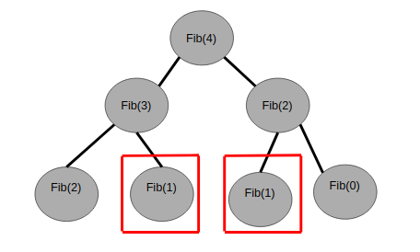
In the above figure, we can see that Fib(1) repeats, hence it follows the overlapping subproblem property also.

Since it follows both optimal substructure and overlapping subproblem property hence we can apply dynamic programming here.

Code
Memoization
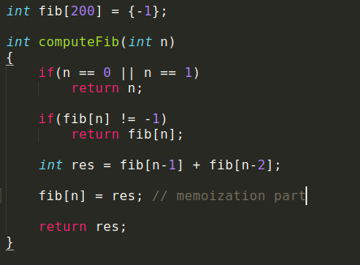

Tabulation
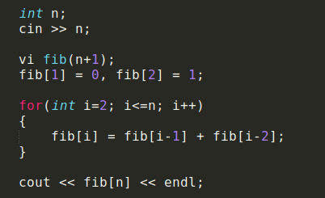
Time complexity: O(n)

